Think of a difficult situation where you wanted to have conflict resolved more positively. Write down your observations and understanding of the situation.
The problem (2-3 sentences)

Who was involved? Who are the main parties?

What was the impact of the situation? What was the response? What were the consequences of the response?

Did the consequences support or challenge your personal beliefs about conflict? In what ways did your response reflect your personal beliefs about conflict?

What did you want to happen?

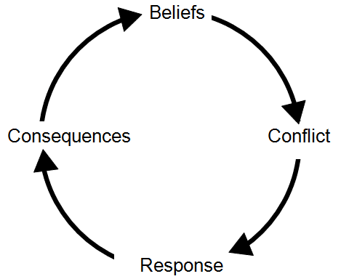

Our beliefs about conflict impact our response and the consequences of that response further impact our beliefs.

Talk about this at your next board meeting.

Refer to the Manitoba Agriculture, Food and Rural Development fact sheet called: Resolving Conflict – Ways to Build Your Organization’s Effectiveness.

